# JavaScript for Front-End – Retake Exam Pet Register

You have been tasked to create a simple Front-End application, which represents **registration form for pets**. You should create an interface that allows users to register their beloved pets.

## Task

The task is split into **2 sub-tasks**:

* A simple but fancy **web page design**.
* A simple but dynamic **web page functionality**.

The clients are understanding people, and they understand that you are quite novice as a developer, so they are willing to accept **ONLY** the **web page design** (without **functionality**) or **ONLY** the **web page functionality** (without **design**), if you are **unable** to **implement** one or the other.

## Overview

### Web Page Design

You are given the HTML file that looks like this **WITHOUT design**:

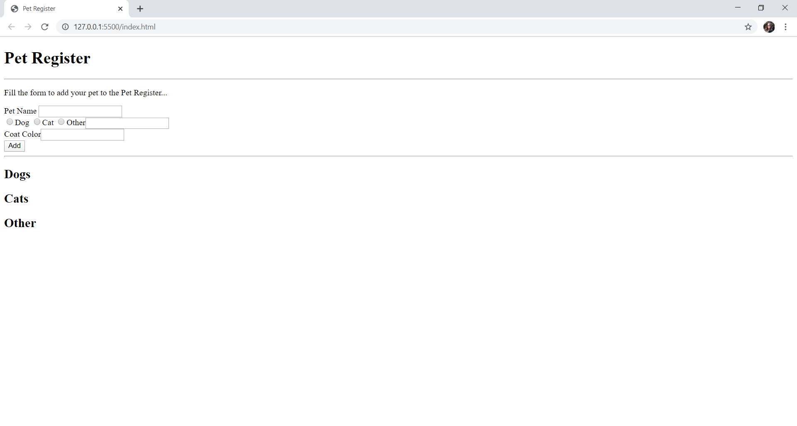

The web page should look like this **WITH design**:

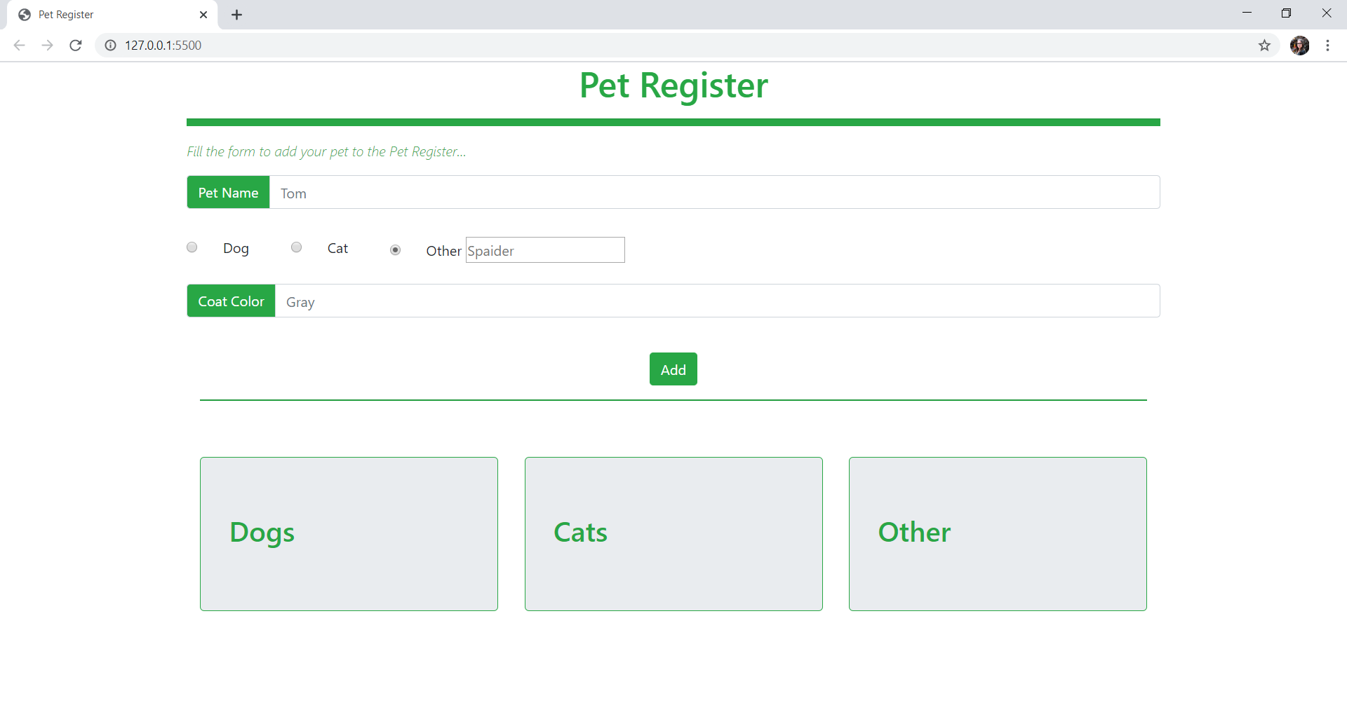

### Web Page Functionality

The application contains the following **functionality** – **collects** the **pet data** and **displays it** into the container of the **selected species**.

The application should provide functionality to **collect** the **pet data**. You are given input fields from diferent types. User shoud enter **name** and **color** and shoud choose a **species**. The **placeholder** **attribute** should be same as given above. Selected by default is the [**Cat**] radio.

**Only** when [Other] is checked, another input field is displayed on the page. Here user shoud enter another species, like it’s shown:

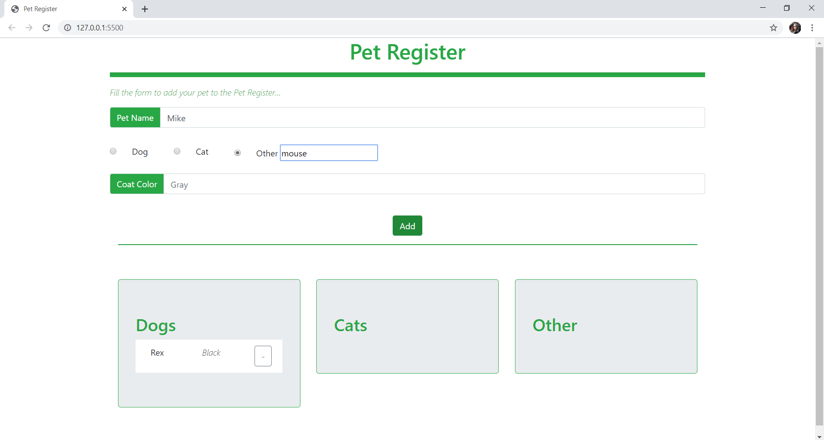

When the [Add] button is cklicked and **all fields** are **filled** you have to empty all of the text fields and display the collected data into the relevant species column in **unordered list item**. Every list item has a delete button [**-**] that deletes the current **<li>**.

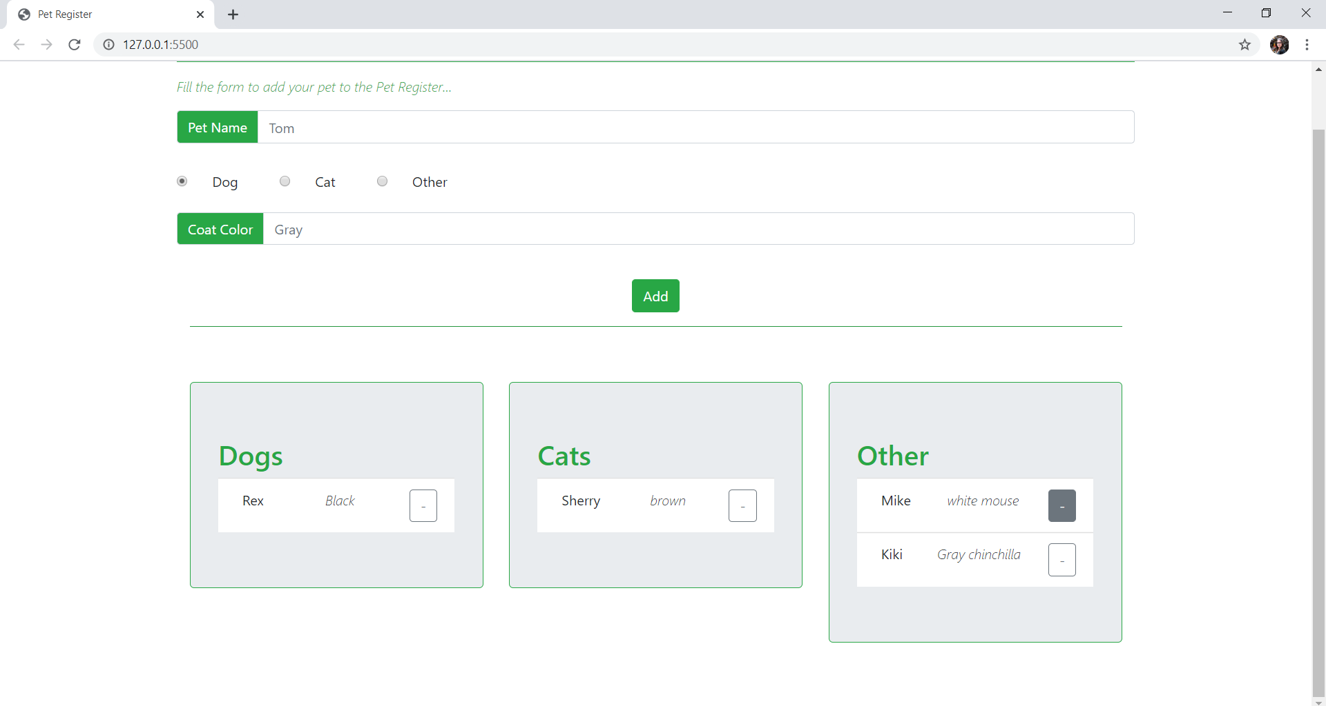

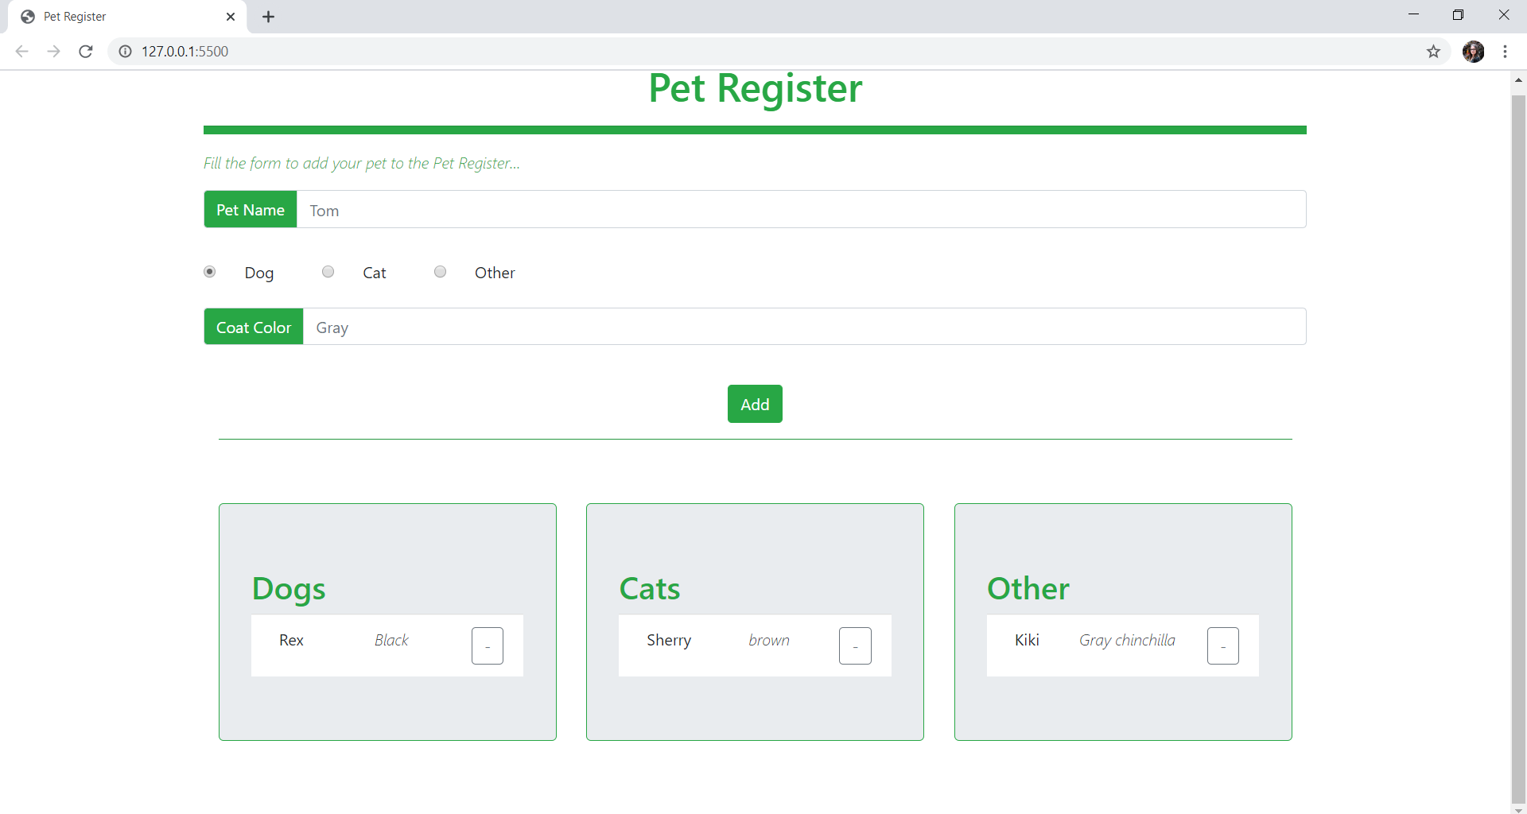

## Constraints

* You must use **ONLY** **Bootstrap** for the **web page design**.
* You must use **ONLY** native **JavaScript** for the **web page functionality**.

## Submitting Your Solution

ZIP your project. Upload the archive to Judge system.